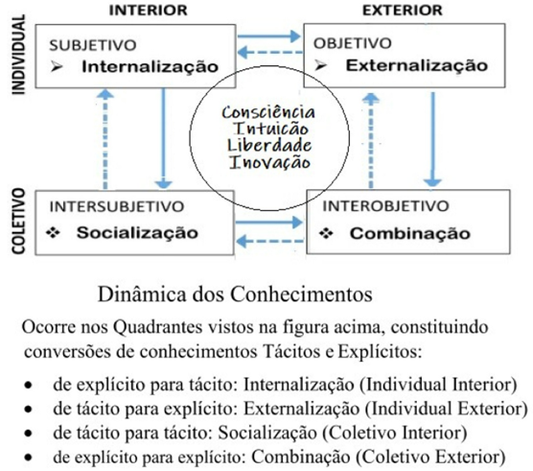

(Nonaka & Takeuchi, 1995)