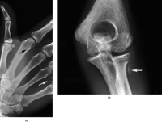(a) Thumb radiograph showing cracks (white arrow) that usually first become visible on the IP edges. As deterioration progresses, cracks appear closer to the clinically used areas of the IP (black arrow). (b) In some instances, early cracking along the edge of the IP does not occur. This crack appears as a lucency near the radius, which could be confused with a foreign body. Artefact remedy: an IP must be replaced when cracks occur in clinically useful areas.

http://bjr.birjournals.org/cgi/content/full/74/878/195#top

