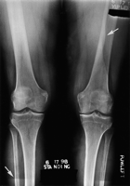
This bilateral knee image was spoiled when the incorrect erasure setting was used to eliminate a previous femur image. Evidence of this is the residual image of the lead marker in the top corner of the image, the tissue line from the previous image (upper arrow) and the additional line of collimation along the bottom of the image (lower arrow). Artefact remedy: radiographers must select the correct erasure setting according to the type of exposure that has occurred.

http://bjr.birjournals.org/cgi/content/full/74/878/195#top

