Here is a familiar reference before being formatted properly by APA 6th ed standards:

Grossman, S. C. and Valiga, T. M. (2005). Followership and empowerment. In The nurse leadership challenge: Creating the future of nursing (2nd ed.). Philadelphia, PA: F. A. Davis Company.

If we go to the second line and place the cursor before the n of nurse, we can then tell Word to use hanging indents:

Click on Format, Paragraph:

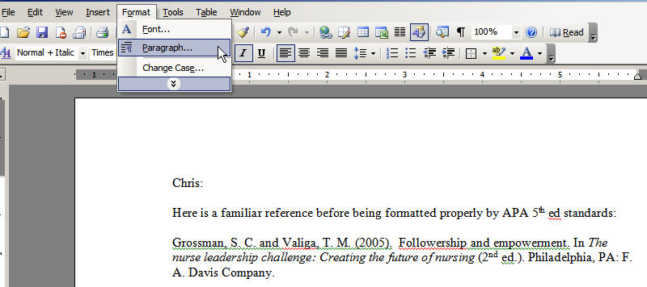

Then you will see the paragraph dialogue box:

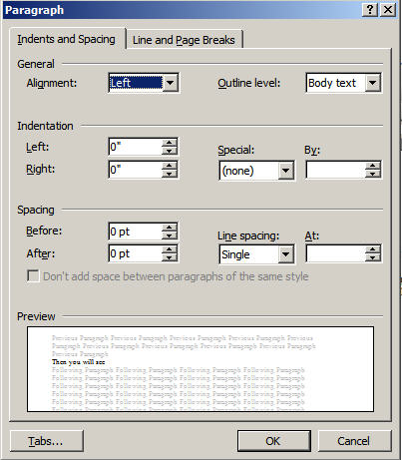

From here, you would choose Special, Hanging, then click OK.

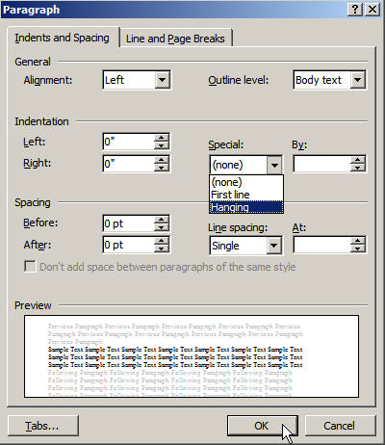

This would turn:

Grossman, S. C. and Valiga, T. M. (2005). Followership and empowerment. In The nurse leadership challenge: Creating the future of nursing (2nd ed.). Philadelphia, PA: F. A. Davis Company.

Into:

Grossman, S. C. and Valiga, T. M. (2005). Followership and empowerment. In The nurse leadership challenge: Creating the future of nursing (2nd ed.). Philadelphia, PA: F. A. Davis Company.

You can always Google “hanging indents in Word” to get more resources.

Jack

