Easy workflow with Moodle Compose windows
When you are posting email or discussion posts in Moodle there are some ways to make your life easier.
If you just want to get text from a Word document, simply select that text and drag and drop the selected text from your Word window to the Moodle compose window:
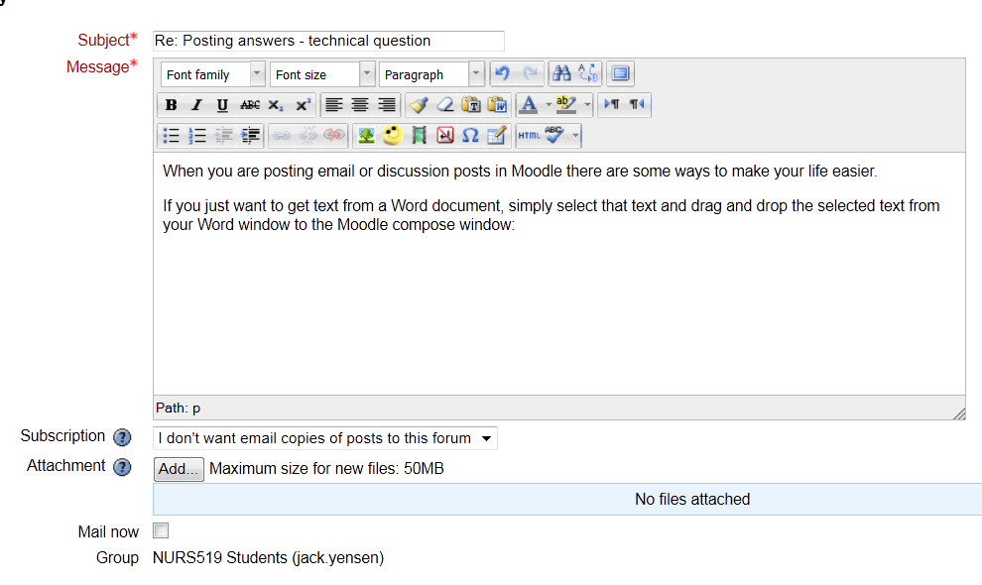
Normally, though, you would want to preserve formatting. In this case copy the Word material you wish to paste (select, then Ctrl-C), then in the Moodle compose window, press the copy from Word icon:
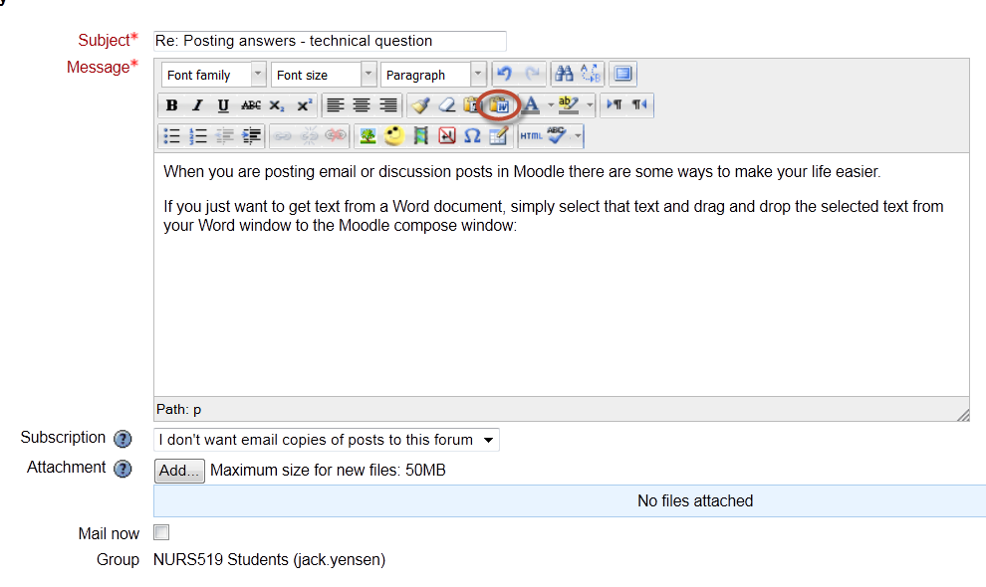
A small window will pop up:
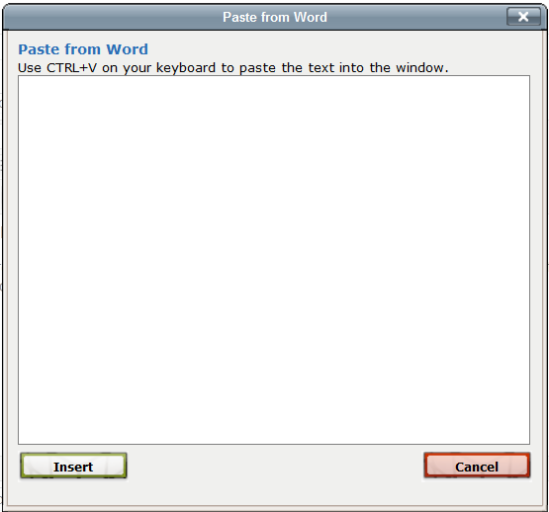
Then Ctrl-V will paste your Word material into this window:
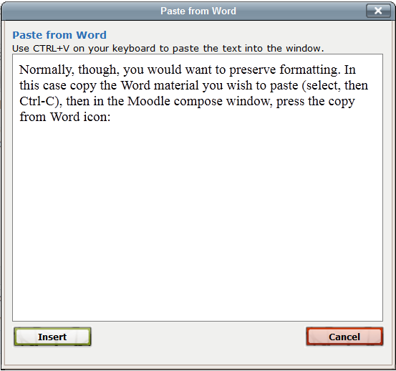
Then, press the Insert button and your Moodle compose window will show:
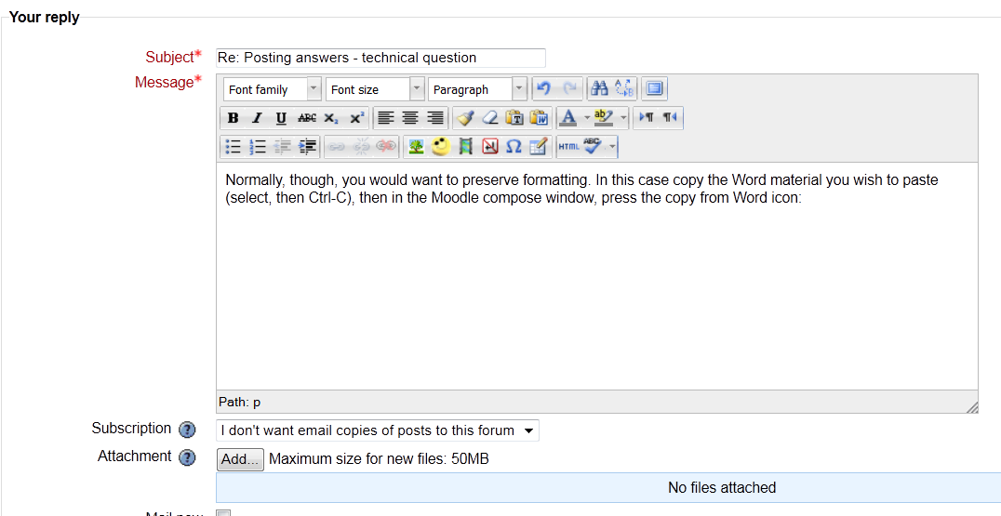
So, this way you can select an entire Word document and copy and paste it into Moodle and preserve the original formatting. This means that everyone can read it, however, for the poor instructor, it is wretched trying to review, comment and grade it in a discussion post format, so it is courteous to attach your Word file too.
Tips and Tricks
When researching your case study questions paper and you find an interesting one like Estrogen effects in allergy and asthma (Bonds & Midoro-Horiuti, 2013), you can add it to your Zotero library:
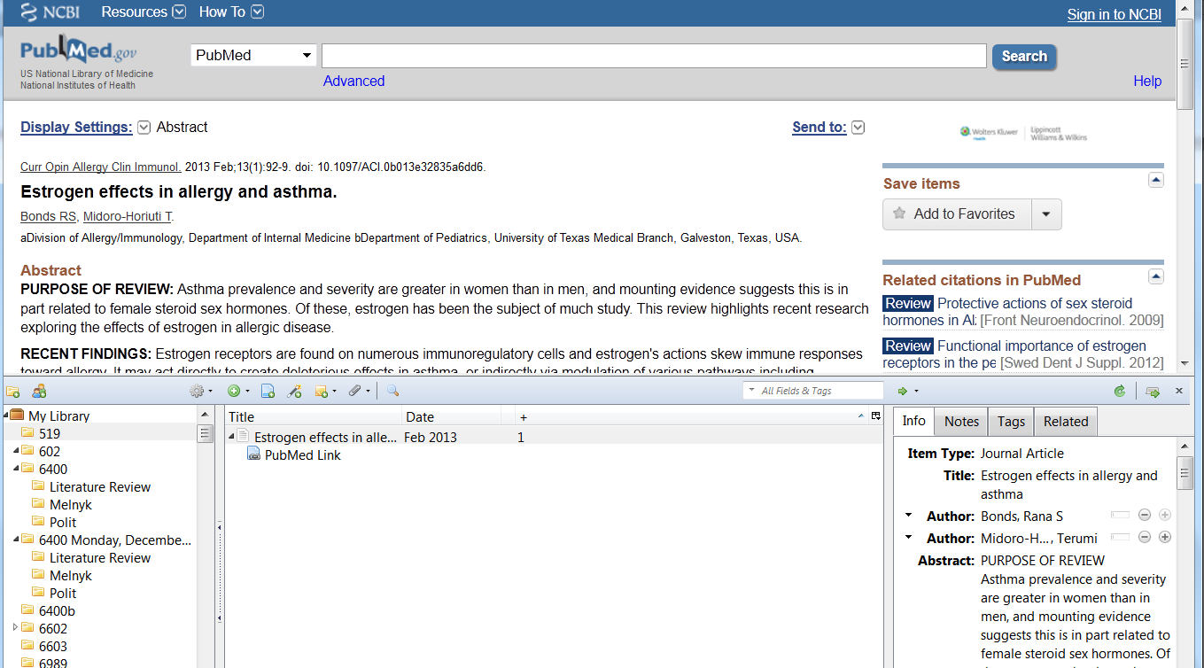

Then, when you are writing your Word paper, you can shift-drag and drop one or more articles from your Zotero folder into your Word document and the inline citations will be added at the cursor point. Once you are done writing and it is time to list your references, simply select all the articles you used in your Zotero window and drag and drop them into your Word document – it’s all done! This simple process can also be used with a Moodle compose window:
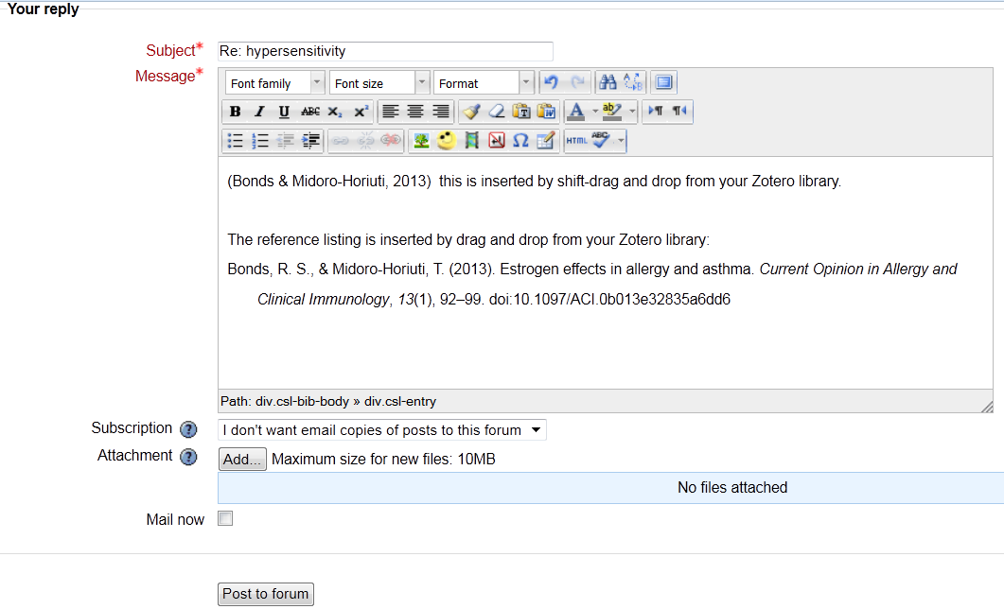
You will notice that this is a very easy way to add references to email or discussion posts and have them properly formatted and with hanging indents. You are now a maestro!

